1. Agenda:
   1. To read MSG ID and MSG Key from the Headers.
2. 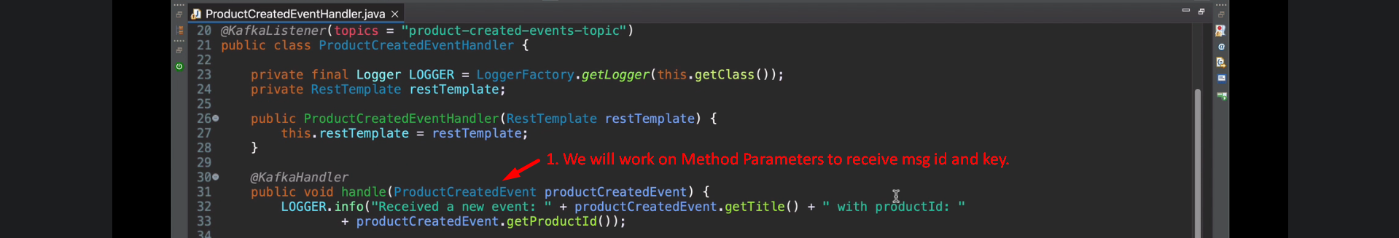
3. 
4. 